Jal Rekha - Dhara
User Manual





M.P. STATE ELECTRONICS DEVELOPMENT CORPORATION LTD.
State IT Centre, 47-A, Arera Hills, Bhopal-462011 (M.P.)
www.mpsedc.mp.gov.in
Table of Contents
1. Introduction 3
2. Workflow Overview of Dhara Module 3
2.1 Scheme-Village Mapping 3
2.2 Component-to-Village Mapping 4
2.3 Bulk Consumer Mapping 4
2.4 Task Assignment 4
2.5 Mobile Application Usage 4
2.6 Approval Process 4
3. Master Data Configuration 4
3.1 Scheme Village Master 4
3.2 Village Mapping with Components 5
3.3 Add Meter in WTP 5
3.4 Bulk Consumer Mapping 6
3.5 Assign Task 6
4. Field Engineer Mobile App – Dhara Module 7
4.1 Login & Sync 7
4.2 Accessing Dhara Module 7
4.3 Selecting Date 7
4.4 Entering Meter Reading 7
4.5 Auto-Mapped Villages 8
4.6 Uploading Photo & Remarks 8
4.7 Review & Upload 8
5. General Manager (GM) Web Portal – Approval Workflow 8
5.1 Login and Navigation 8
5.2 Reviewing Meter Readings 8
5.3 Edit or Approve 8
5.4 Approval Rules 9
5.5 Component-specific Screens 9

1. Introduction
One of the key challenges in implementing water supply schemes is ensuring that contractors supply the required quantity of water regularly. Manual reporting often leads to inconsistencies, making monitoring and billing processes inefficient.
To overcome this, the Jal Rekha system includes a specialized module named ‘Dhara’, designed for real-time monitoring of water supply through geotagged photographs of meter readings. Field Engineers (FEs) capture readings from various water supply components including:
- Intake Points
- Water Treatment Plants (WTPs)
- Overhead Tanks (OHTs)
- Village Supply Points
- Bulk Consumers
This real-time data ensures transparency and accuracy in verifying water supply. As a result, contractor payments are processed based on verifiable data, rather than manual logs.

2. Workflow Overview of Dhara Module
The Dhara module consists of the following key workflows:

2.1 Scheme-Village Mapping
Each village is mapped to a scheme in the master data. The village status should be marked as one of the following:
- "O&M Village"
- "Water Supply Started"
- "Bulk Village"

2.2 Component-to-Village Mapping
Each village must be linked to the component (e.g., WTP or OHT) supplying water to it. The component could be from the same or a different scheme under the same PIU.

2.3 Bulk Consumer Mapping
If there are bulk consumers (e.g., industries, institutions), they must be mapped to the scheme and the supplying component.

2.4 Task Assignment
Once mappings are completed, the General Manager (GM) assigns the mapped components (villages or bulk consumers) to Field Engineers (FEs) for daily meter reading.

2.5 Mobile Application Usage
Assigned Field Engineers use the Jal Rekha mobile app to enter and upload meter readings.

2.6 Approval Process
The GM reviews the submitted readings, edits if necessary, and approves them. Approved readings are linked to the billing module.

3. Master Data Configuration

3.1 Scheme Village Master

The Scheme Village Master is used to map villages with their respective water supply schemes and update their operational status. This forms the foundation for accurate water supply monitoring and meter reading assignments in the Dhara module.

Steps:
- Navigation:
  - Go to Master > Scheme Village Master from the side menu.
- View Existing Mappings:
  - A table shows the list of mapped villages with fields like:
    - Scheme Name
    - Village Code
    - District, Block, Gram Panchayat (GP)
    - Flags for: O&M Village, Water Supply Started, Bulk Village
- Add New Mapping:
  - Click “+ Add Village” to open the popup form.
- Fill Village Details:
  - Select values from dropdowns:
    - Scheme, District, Block, GP, Village
  - Mark status using Yes/No:
    - Is O&M Declared Village?
    - Is Water Supply Started?
    - Is it a Bulk Village?
  - PIU field is auto-filled.
- Save Mapping:
  - Click “Mapped Village” to save the configuration.
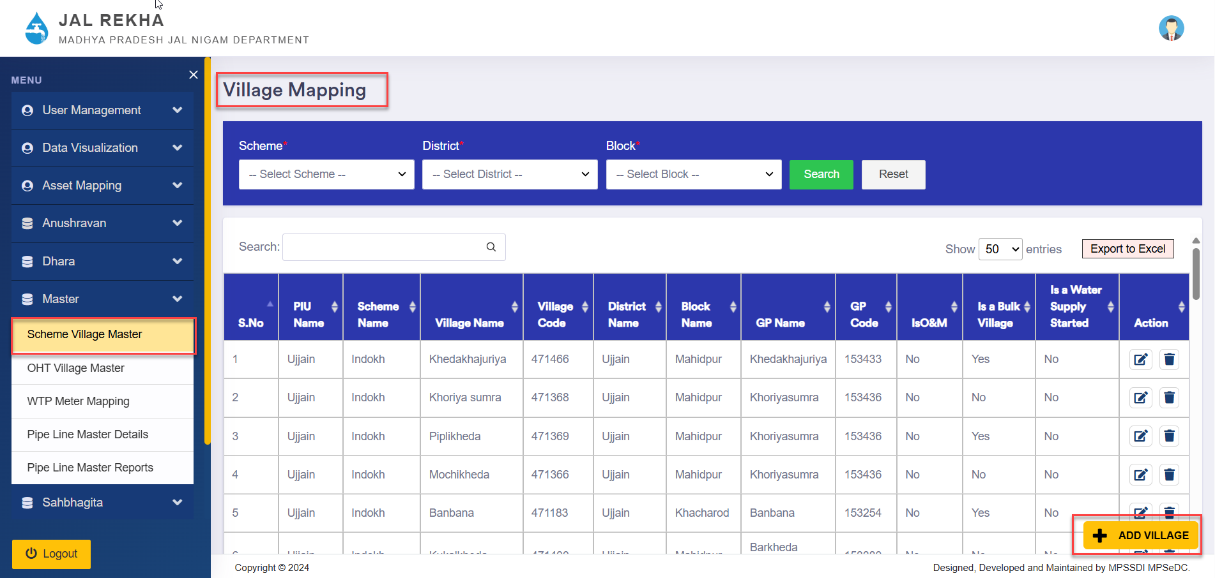


3.2 Village Mapping with Components

After identifying the villages where water supply has started, it is necessary to map the source component (Overhead Tank or Water Treatment Plant) that supplies water to each village or habitation. This mapping ensures accurate tracking of the water source and supports the operational functionality of the Dhara module.

Steps:
- Navigation:
  - Master > OHT Village Master from the side menu.
  - A tabular view will appear displaying existing mappings, including Component Name, Village Name, Capacity, FHTC, and Operator details.
- View Existing Mappings:
  - Table displays Component, Village, Capacity, FHTC, Operator details.
- Add New Mapping:
  - Click + Add New to open the mapping popup.
- Select Village Details:
  - In the "Select Village to Mapping" section, select the following details from dropdown menus:
    - Scheme Name
    - District Name
    - Block Name
    - GP Name
    - Village Name
    - Habitation Name(s)
- Select Component:
  - Choose Component (OHT/WTP) and Scheme.
  - Based on the scenario, proceed with one of the following case.

Cases:

Case 1: Mapping with OHT of Same or Different Scheme
- OHT is in Same Scheme:
Select the OHT component from the same scheme.
- OHT is in Different Scheme (Same PIU):
  - Check the box: “Water Supply through other Scheme of PIU”
  - Select the OHT from another scheme.
- Enter the required details:
  - FHTC
  - Capacity (in KL)
  - Operator Name
  - Operator Contact Number
- Click on “Map Village” to save the mapping.

Case 2: Mapping with WTP
- WTP of Same Scheme:
Select the WTP component from the same scheme.
- WTP of Different Scheme (Same PIU):
  - Check the box: “Water Supply through other Scheme of PIU”
  - Choose the WTP from another scheme.
- Fill in the remaining details as in Case 1 and click “Map Village”.

Case 3: Mapping Multiple Habitations to Different Components
In some scenarios, different habitations within the same village are supplied water by different components.
- From the Habitation Name dropdown, select habitations one by one.
- For each habitation:
  - Select the corresponding component (OHT or WTP) and scheme.
  - Enter the required details: FHTC, Capacity, Operator info.
  - Click “Map Village” after each habitation-component mapping.

Map-Based Visualization:
- To assist in selecting habitations accurately, click on the map icon beside the Habitation Name field.
- A map view will open showing village boundaries and habitations.
- Use “Select All”, “Clear All”, or manually choose habitations on the map.
- This spatial view ensures precise mapping based on geography.
This flexible mapping system supports real-world configurations where water is supplied from multiple components to different parts of the same village, enabling robust planning, monitoring, and billing.
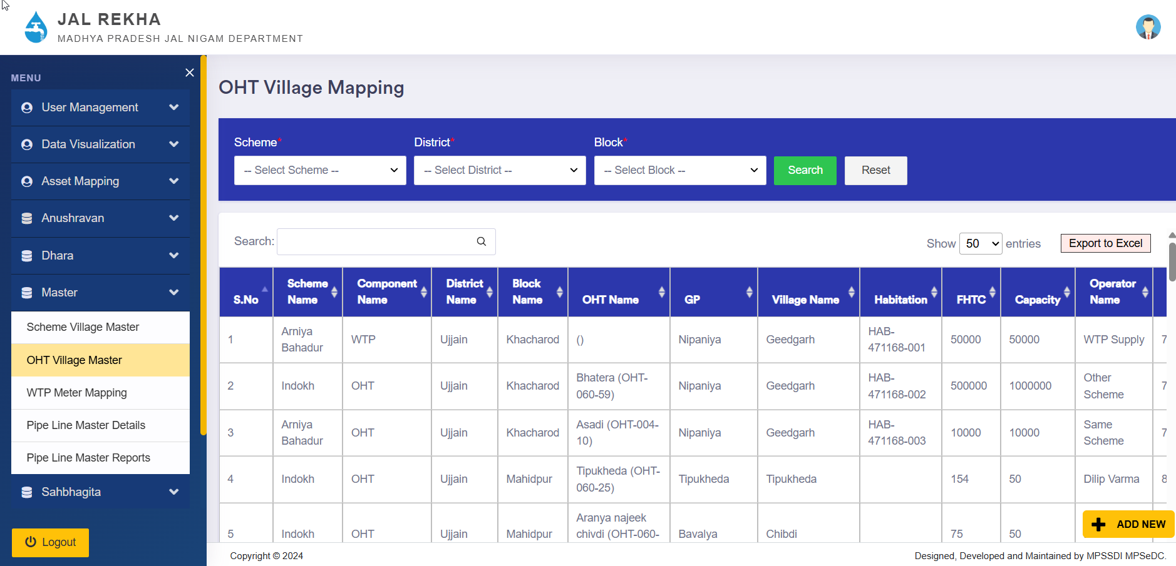


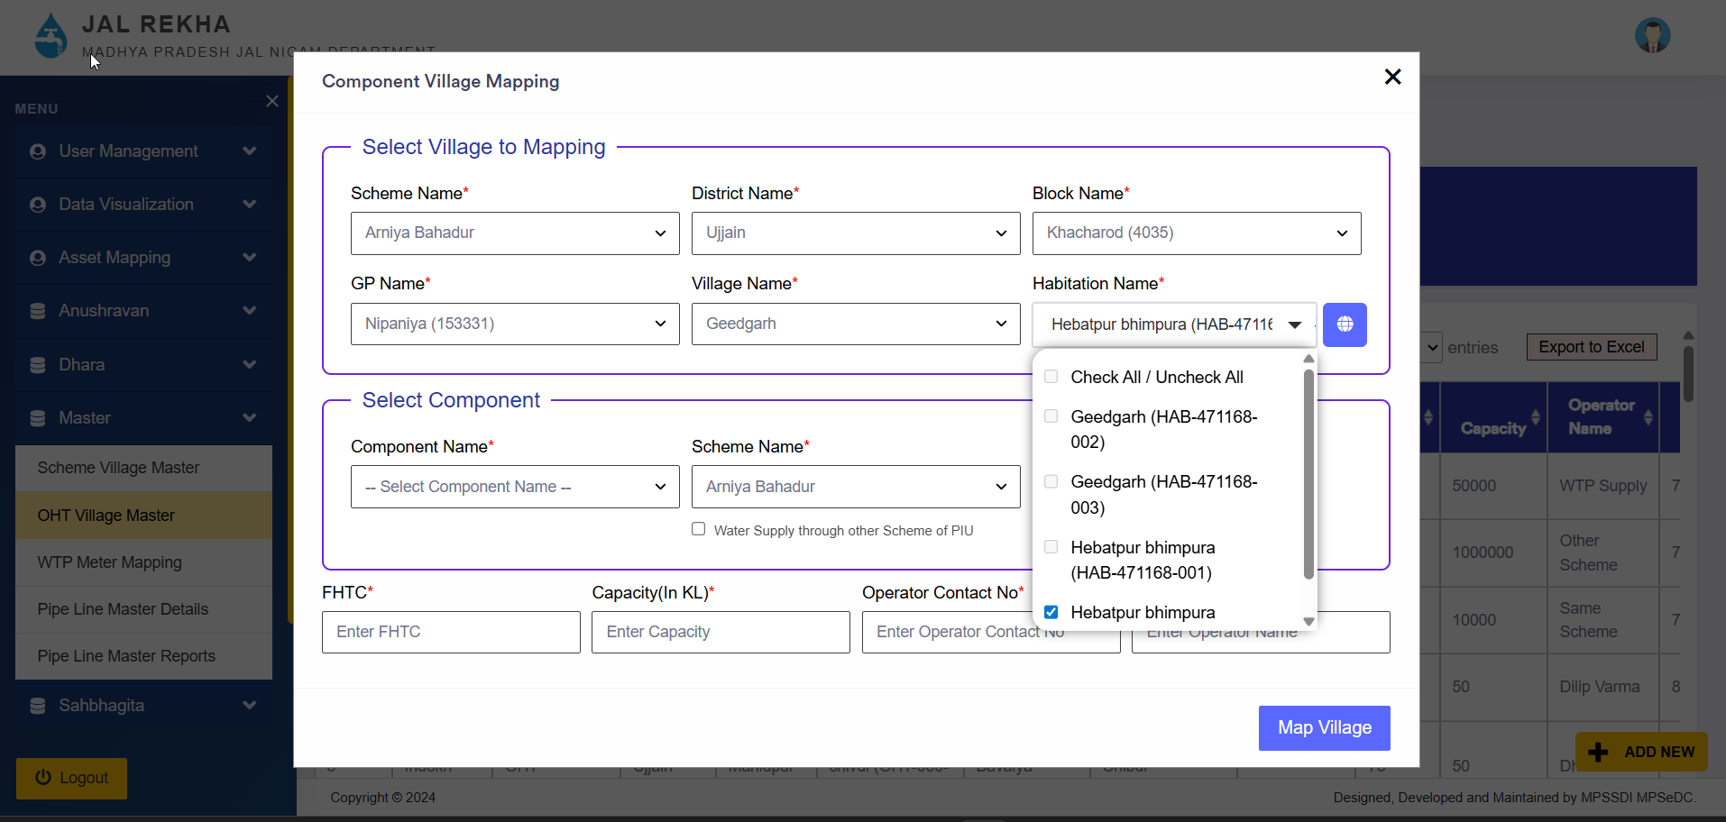
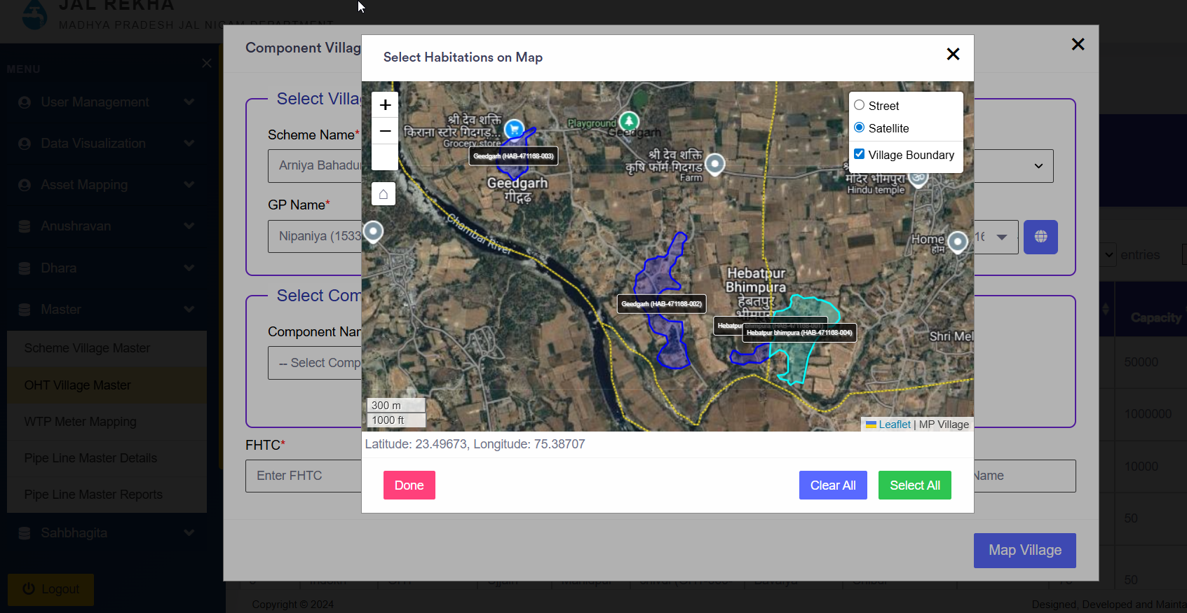

3.3 Add Meter in WTP

In many schemes, a single Water Treatment Plant (WTP) may have multiple meters installed to monitor water output to different supply lines or components. The WTP Meter Mapping functionality allows users to map multiple meters to a specific WTP.

Steps:
- Navigation
  - From the side menu, go to:
Master > WTP Meter Mapping
- View Existing Mappings
  - The main screen shows a table listing all previously mapped meters along with:
    - Meter Name
    - WTP Name
    - Associated Actions (like delete)
- Add New Meter Mapping
  - To map a new meter, click on the “+ Add New” button in the bottom-right corner.
  - A pop-up window titled “WTP Meter Mapping” will appear.
- Fill Mapping Details
  - In the pop-up form, select the following from dropdowns:
    - WTP Name
    - District
    - OHT Name (linked to the WTP)
  - Enter the Meter Name in the input field.
- Map the Meter
  - Once all fields are completed, click the “Map Meter” button to save the mapping.
This setup ensures accurate monitoring and reporting of water supply readings from different meters connected to a WTP.
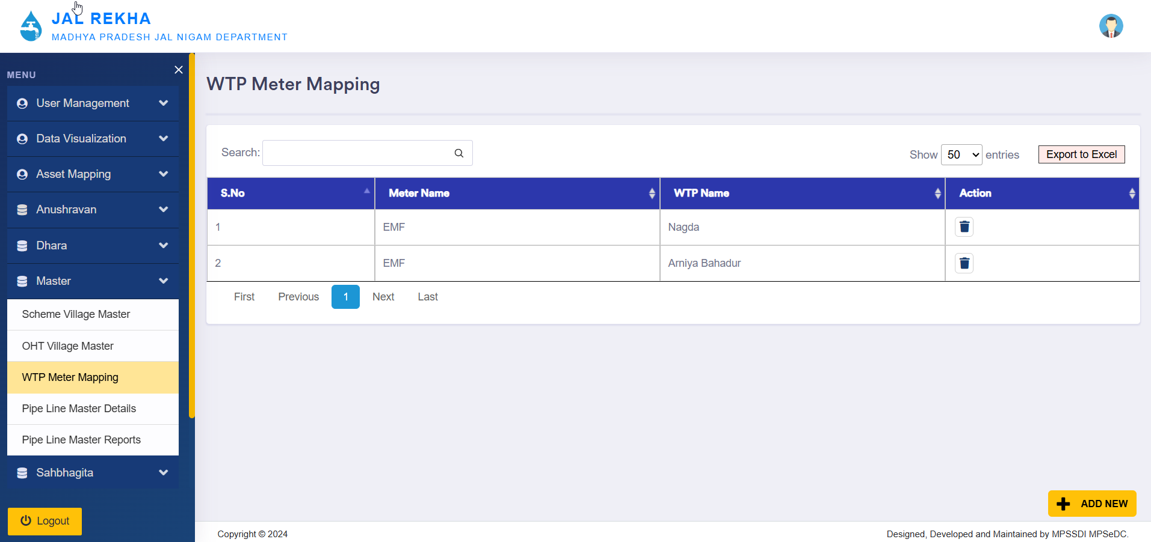
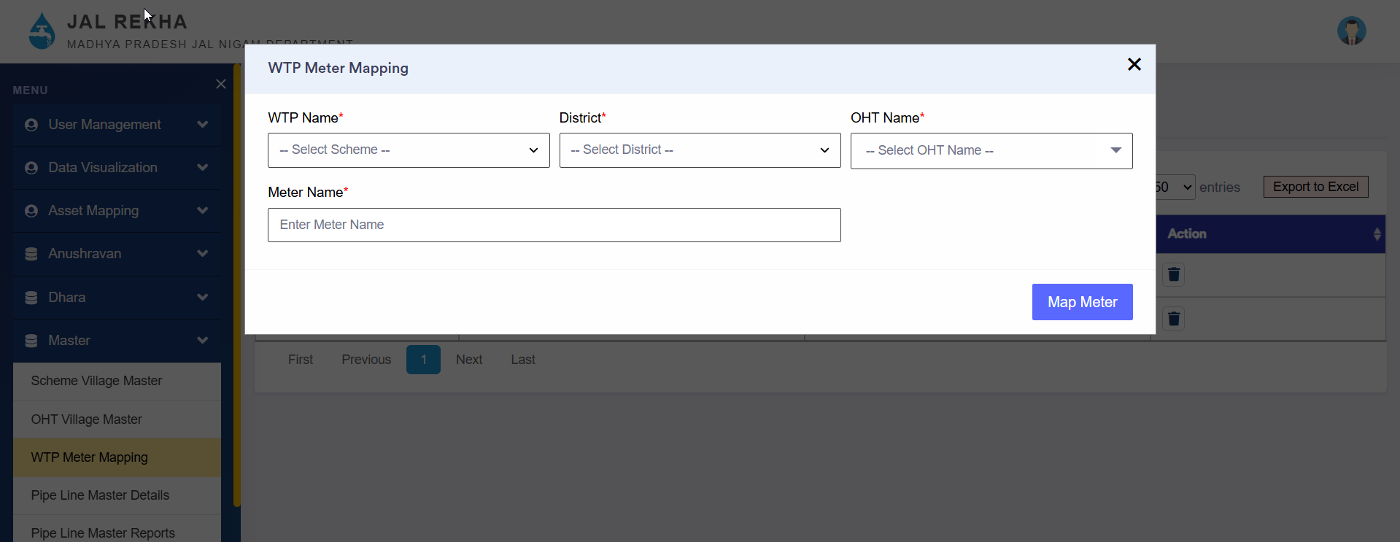

3.4 Bulk Consumer Mapping
To add bulk consumers, users need to navigate to the sidebar and click on “Bulk Consumer Mapping” under the Dhara Module.
On this screen, users can view the list of already mapped consumers. To add a new bulk consumer, click on the “+ Add New” button. A new pop-up window will appear.

Steps:
- Select Scheme: Choose the scheme under which the consumer is being mapped.
- Select Component: Choose the component (e.g., Intake, OHT) through which water is being supplied.
- Scheme Boundary Selection:
  - Select whether the consumer is inside or outside the selected scheme boundary.
  - If the consumer is inside, only districts under the selected scheme will be listed.
  - If the consumer is outside, all districts except those under the selected scheme will be shown.
- Select Consumer Type:
  - Urban:
    - Select District
    - Select ULB (Urban Local Body)
    - Enter Latitude and Longitude
    - Enter Daily Contract Demand (KLD)
    - Enter Consumer Name (e.g., Beneficiary, Institute, Industry)
    - Upload the Agreement file (PDF, max 5 MB)
  - Rural:
    - Select District
    - Select Block
    - Select Gram Panchayat
    - Select Village
    - Enter Latitude and Longitude
    - Enter Daily Contract Demand (KLD)
    - Enter Consumer Name (e.g., Beneficiary, Institute, Industry)
    - Upload the Agreement file (PDF, max 5 MB)
- Click Save to complete the mapping.
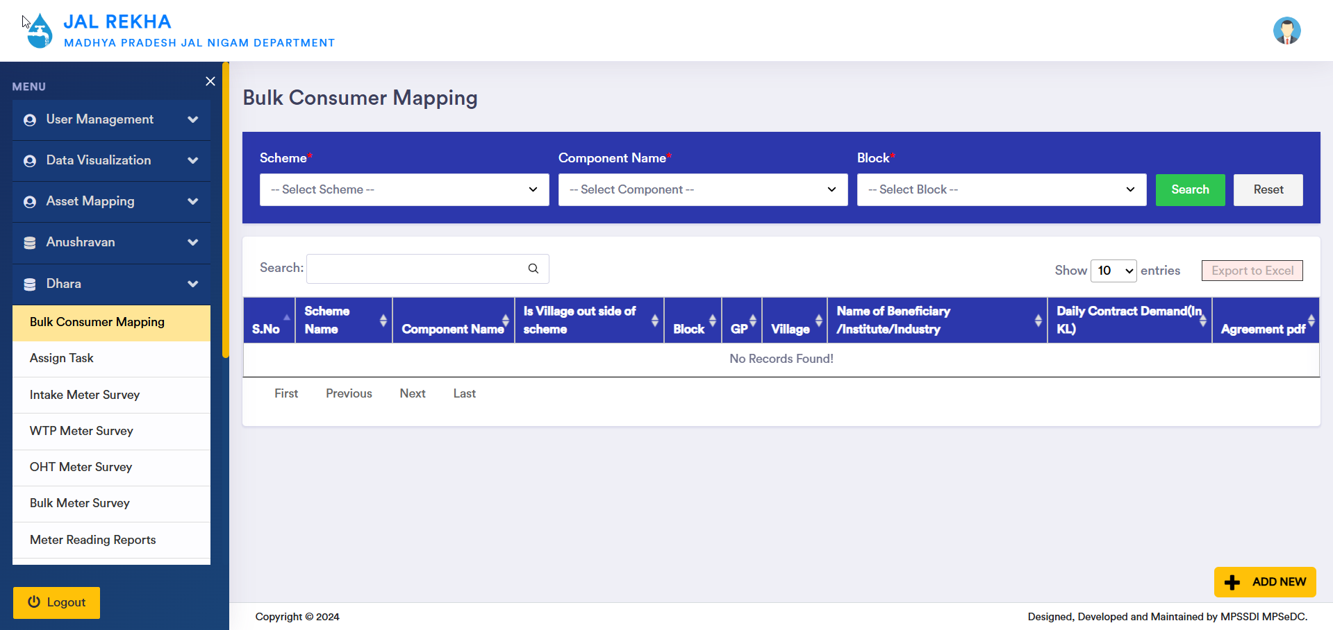
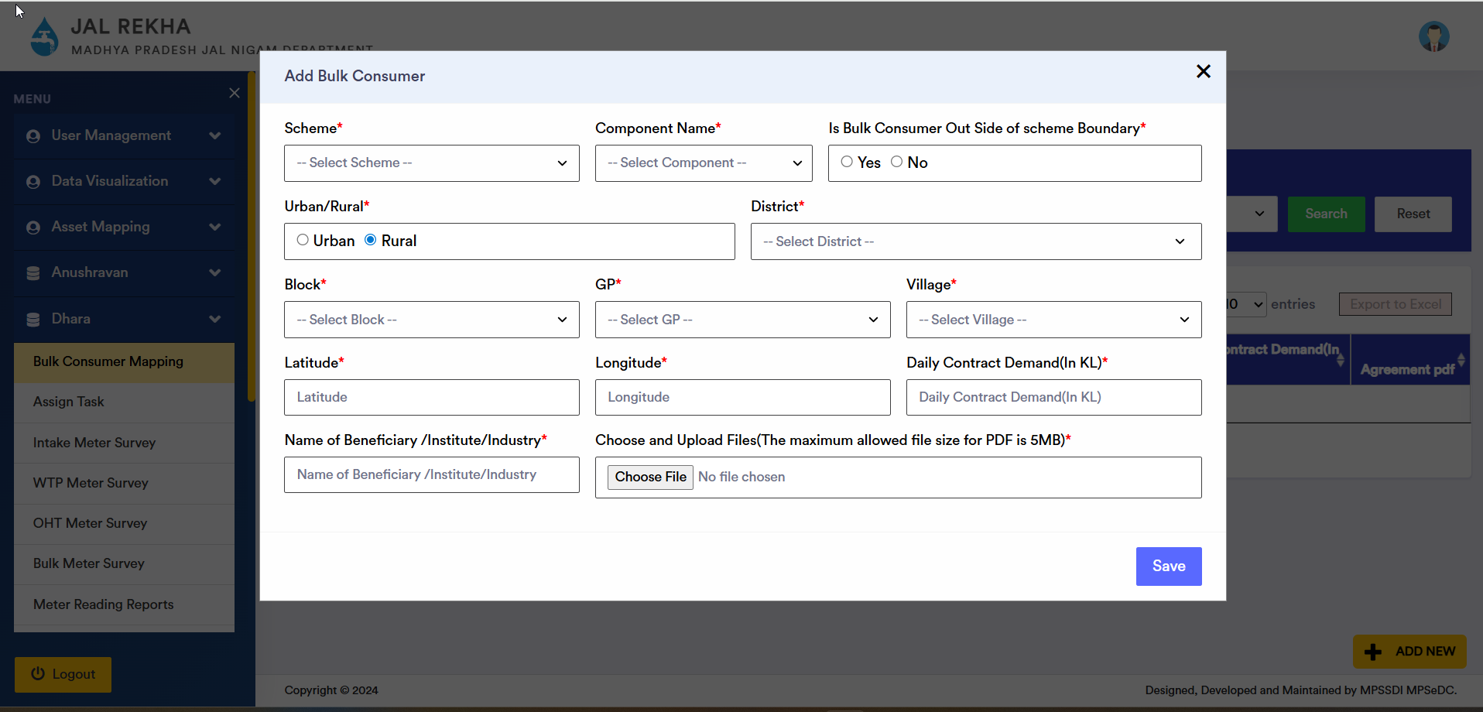
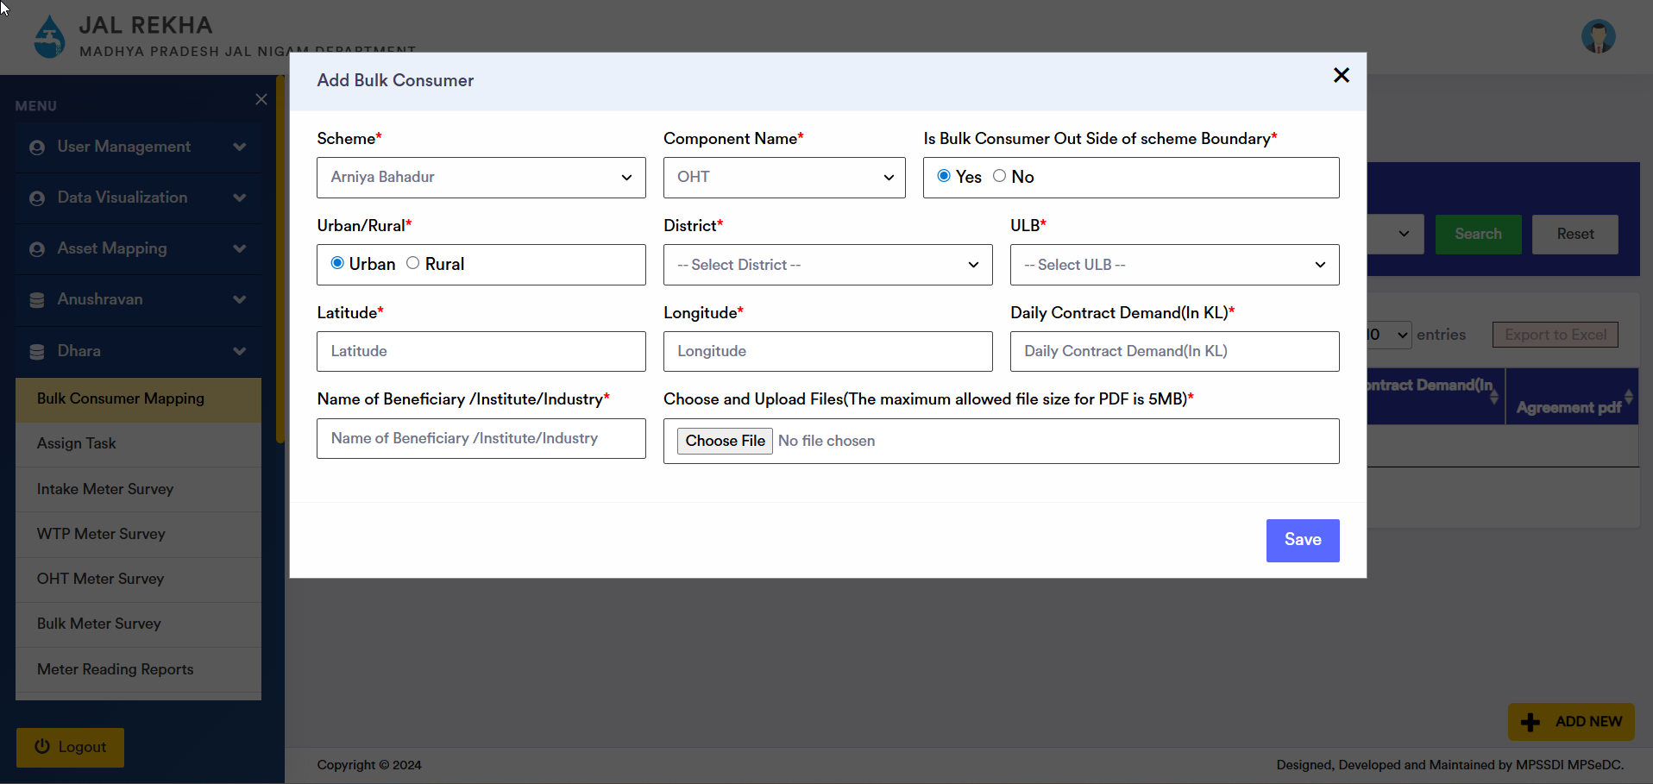

3.5 Assign Task
After completing all relevant mappings (villages, components, meters, bulk consumers), the General Manager (GM) is responsible for assigning components to Field Engineers or Assistant Engineers for daily meter reading and monitoring activities.

Steps:
- Navigation
  - Go to Dhara > Assign from the left sidebar.
- Select User Type
  - Choose either:
    - Field Engineer
    - Assistant Engineer
- Select Engineer
  - Based on the selected user type, the corresponding list of users will appear in the “Select Field/Assistant Engineer” dropdown.
- Select Scheme
  - Choose the relevant scheme from the Scheme dropdown.
- Select Component
  - From the Component dropdown, choose one of the following:
    - Intake
    - WTP (Water Treatment Plant)
    - ESR (Elevated Service Reservoir)
    - Bulk Consumer
- Component-Specific Selection
  - If ESR is selected: an additional dropdown appears to select a specific ESR.
  - If Bulk Consumer is selected: a dropdown appears to select the relevant Bulk Consumer.
- Assign Task
  - Click the “Assign” button to allocate the selected component to the chosen engineer.
- Task List View
  - All assigned components are displayed in the Assign Task List below.
  - The list includes:
    - Serial Number
    - District Name
    - PIU Name
    - User Type
    - Intake/WTP/OHT Name
    - Component Name
    - Assigned To
    - Action
- Deactivate Assignments
  - The GM also has the authority to deactivate any assigned task using the “Deactivate” button under the Action column.
  - This allows real-time updates and control over assignments based on staffing or operational needs.
- Export Functionality
- The entire task assignment list can be exported to Excel using the “Export to Excel” button for record-keeping and reporting.
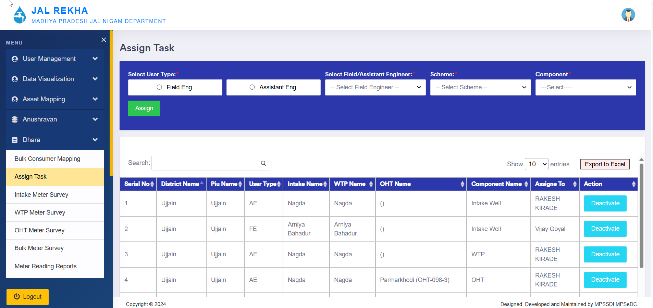

4. Field Engineer Mobile App – Dhara Module

4.1 Login & Sync
- Field Engineer (FE) logs in using valid credentials.
- After login, the user sees all modules assigned to them.
- Before proceeding, the user must synchronize the app to:
  - Fetch latest data (e.g., newly assigned villages/components).
  - Ensure accurate and up-to-date information.

4.2 Accessing Dhara Module
- Tap on the “Dhara” module.
- A list of assigned tasks/components (Intake, WTP, OHTs, Villages) is shown.
- If villages are assigned under multiple schemes, the user must first select the scheme.

4.3 Selecting Date
- User can add readings for:
  - Current Day, or
  - Previous Day (if missed earlier).
- ⚠️ If the user selects Current Day, they will not be allowed to fill previous day's reading afterward.
  - A warning message is shown.
  - If the user confirms, only current day entry is allowed.

4.4 Entering Meter Reading
- Select component (e.g., Intake, WTP, OHT)
- Choose Meter Condition:
  - Meter Functioning: Enter End Reading only
  - Meter Replaced: Enter Start and End Reading
  - Meter Not Functioning: System fills old values; enter approximate supply
  - No Water Supplied: System shows zero supply

4.5 Auto-Mapped Villages
- If a village is linked to WTP or OHT, its name will auto-display under that component.
- User can enter readings for each linked village accordingly.

4.6 Uploading Photo & Remarks
- Capture meter image from camera or upload from gallery
- Remarks optional
- Submit entry

4.7 Review & Upload
- After submitting, data can be:
  - Edited
  - Deleted and re-entered
  - Uploaded to server (finalizes entry)
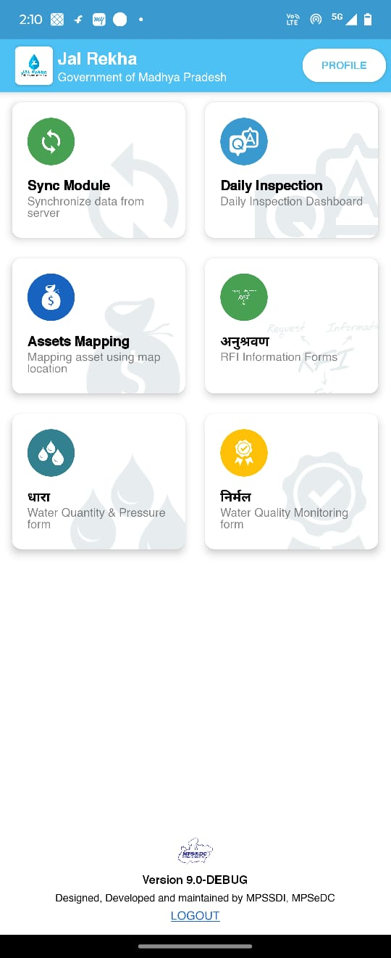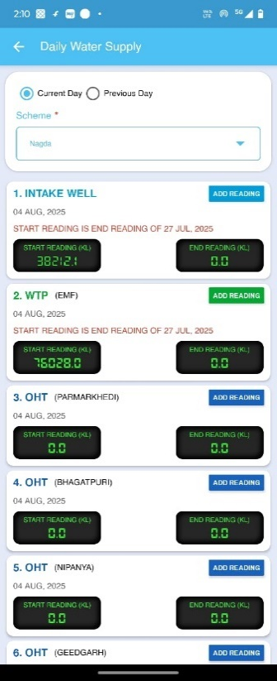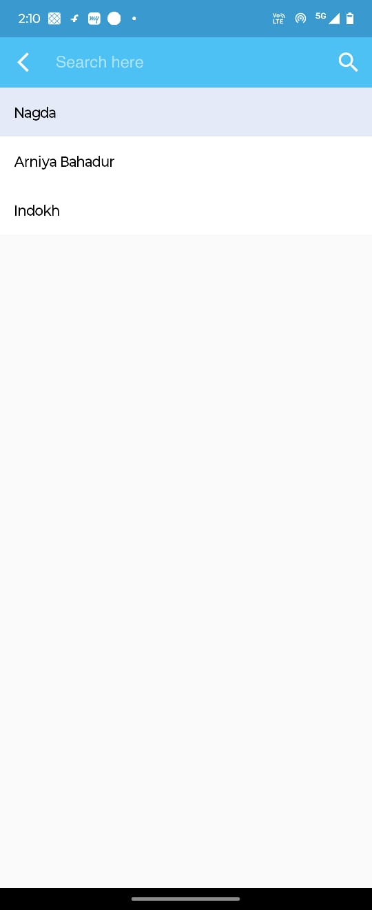
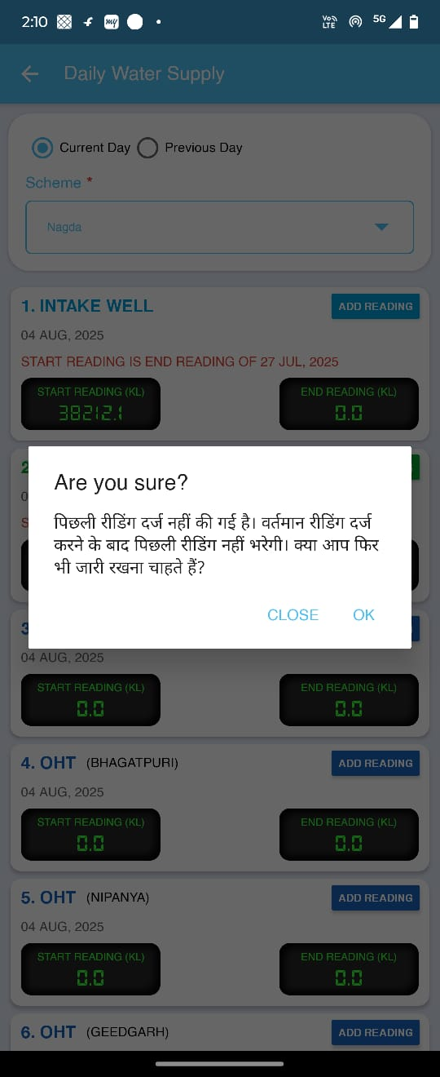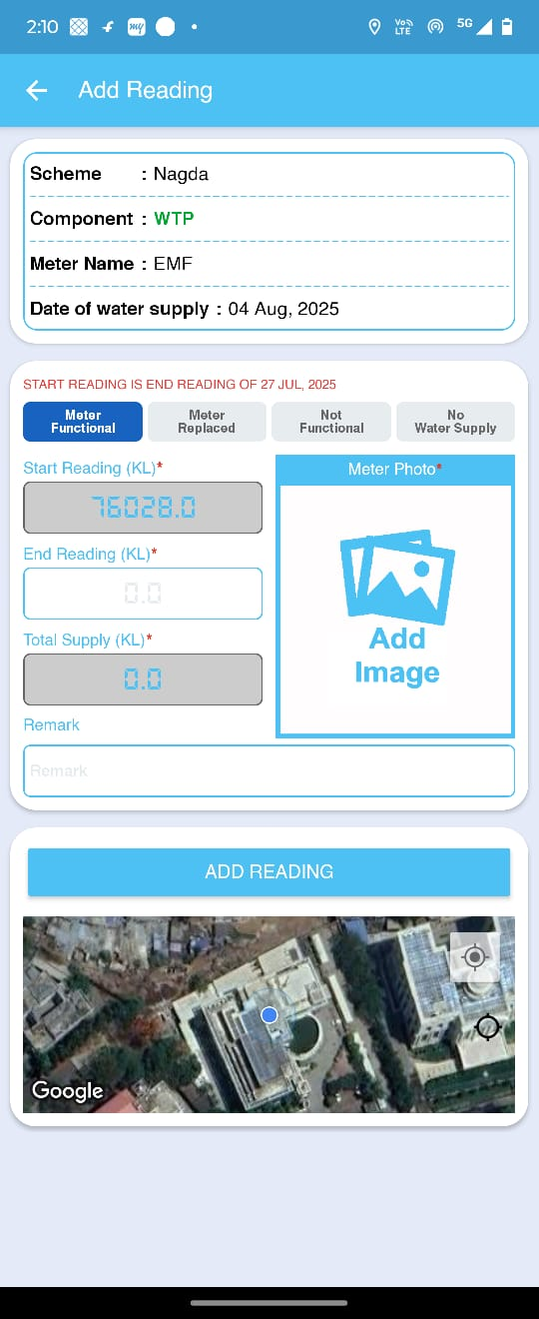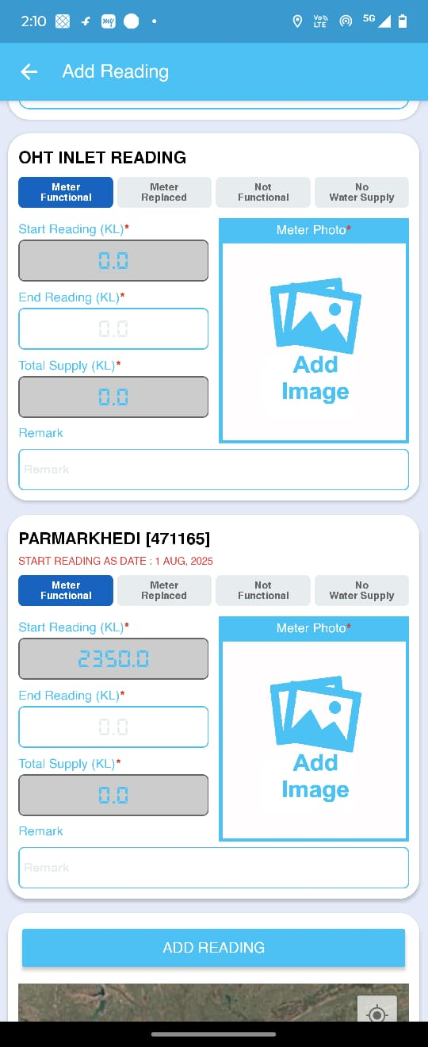

5. General Manager (GM) Web Portal – Approval Workflow

To allow General Managers (GMs) to review, edit, and approve meter readings submitted by Field Engineers (FEs) for various components such as Intake, WTP, and OHT.

5.1 Login and Navigation
- GM logs into Jal Rekha portal
- Navigate to:
  - Intake Meter Survey
  - WTP Meter Survey
  - OHT Meter Survey
- Each menu option opens the respective meter reading review screen.

5.2 Reviewing Meter Readings
- Upon selecting any of the above survey types, the system displays a table containing meter reading data submitted by the Field Engineer.
- The table includes the following columns:
  - Serial Number
  - Scheme Name
  - Meter Start Reading
  - Meter End Reading
  - Total Water Drawn (in KL)
  - Survey Date
  - Latitude and Longitude
  - Image (if uploaded by FE)
  - FE Remark (optional)
  - GM Remark (editable)
  - Status (Pending or Approved)
  - Action (Add/Edit button)
- Filters are available to search by scheme, component, or date.
- Data can also be exported to Excel

5.3 Edit or Approve
- Click on the Add/Edit button under the Action column.
- A popup window opens with the following fields:
  - Scheme Name
  - Component Name (Intake, WTP, OHT)
  - Name of Village (if applicable)
  - Habitation Name (if applicable)
  - Start Reading and End Reading (editable)
  - Total Raw Water Drawn (calculated or entered)
  - Survey Date
  - Survey Remarks
  - GM Remark
- GM can view and, if needed, modify any field before approval.
After editing, the GM must click on the Approve button on the main screen to finalize approval

5.4 Approval Rules
- GM can only approve meter readings for the current day if:
  - The previous day's readings are already approved.
- GM cannot approve readings for the current month unless:
  - All readings from the previous months have been approved.
- Once a reading is approved:
  - It becomes non-editable.
  - The status changes from Pending to Approved.

5.5 Component-specific Screens
- Intake Survey – Review water drawn from intake
- WTP Survey – Track treated water output
- OHT Survey – Monitor storage and supply at tank level
